For loop Scripts:

* Simple for loop output

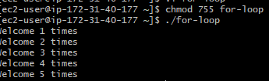

* Simple for loop output

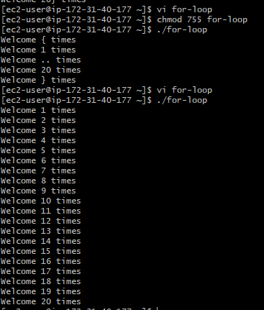

* Simple for loop output.

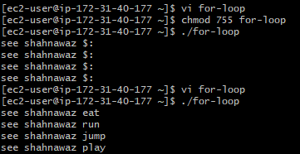

* For loop to delete 5 files

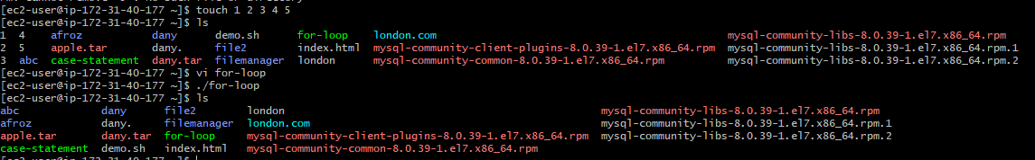

* Specify day in for loop.

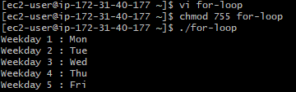

* List all users one by one from /etc/passwd file.

